****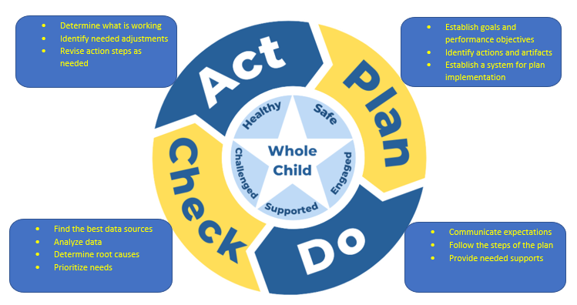

**Review the current School Improvement Plan. List the main initiatives that the school is working on.**

Initiatives:

1. ______________________________________________________________________________
2. ______________________________________________________________________________
3. ______________________________________________________________________________

**Review the data.**

School’s current CCRPI Score __________ Last year’s CCRPI Score ________

Did CCRPI increase or decrease? Why? _____________________________________________________

_____________________________________________________________________________________

What does the school’s test scores look like? Is there any trend? Any one area of weakness that stands out? What is the school strong in? Why? __________________________________________________

_________________________________________________________________________________________________________________________________________________________________________________________________________________________________________________________________________________________________________________________________________________________________________________________________________________________________________

Do the initiatives meet the needs indicated by the data? Why or why not? ________________________

__________________________________________________________________________________________________________________________________________________________________________